Transition Pack for A Level Chemistry

Get ready for A-level!

A guide to help you get ready for A-level Chemistry, including everything from topic guides to days out and online learning courses.

Please note: these resources are non-board specific. Please direct your students to the specifics of where this knowledge and skills most apply.

This resource is strictly for the use of member schools for as long as they remain members of The PiXL Club. It may not be copied, sold nor transferred to a third party or used by the school after membership ceases. Until such time it may be freely used within the member school.

All opinions and contributions are those of the authors. The contents of this resource are not connected with nor endorsed by any other company, organisation or institution.
1
www.pixl.org.uk The PiXL Club Ltd, Company number 07321607 © Copyright The PiXL Club Ltd, 2016

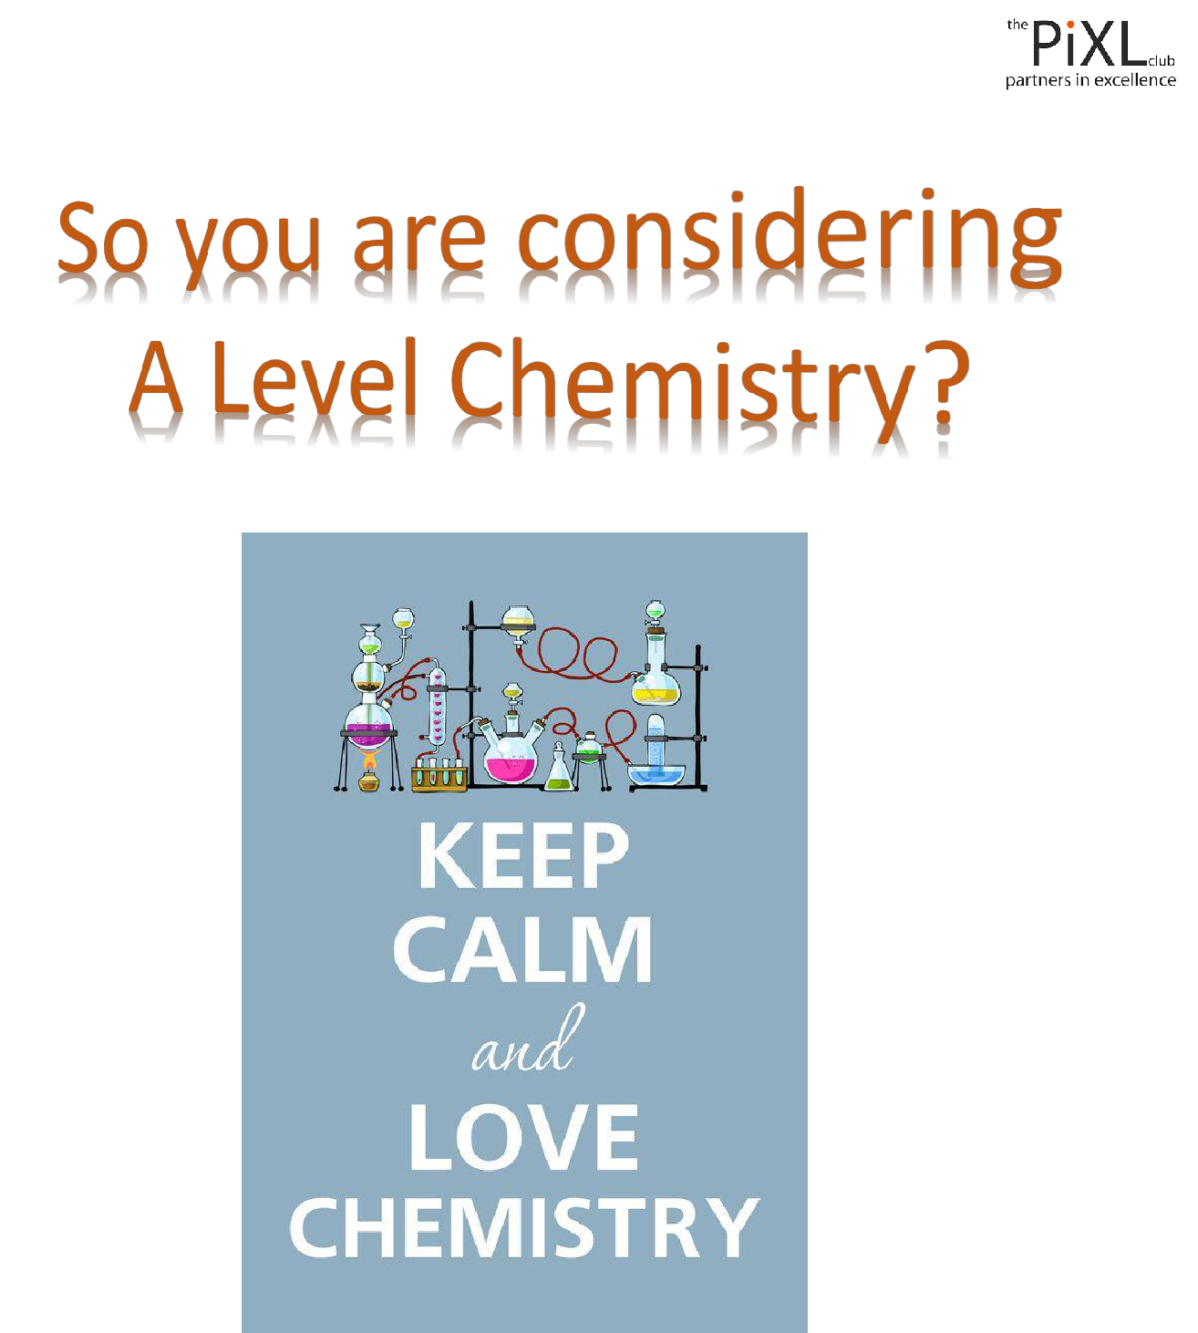

This pack contains a programme of activities and resources to prepare you to start an A level in Chemistry in September. It is aimed to be used after you complete your GCSE, throughout the remainder of the summer term. It has been split into two tasks.

Task 1 Deadline 19th June
Task 2 Deadline 10th July

Please hand your work in to Mr Simmons at simmons.a@kevi.org.uk

Task 1
Research activity & Pre-Knowledge Topic 1-4

To get the best grades in A-level Chemistry you will have to get good at completing independent research and making your own nots on difficult topics. Below are links to 5 websites that cover some interesting Chemistry topics.

Using the Cornell notes system: http://coe.jmu.edu/learningtoolbox/cornellnotes.html make 1 page of notes each from your choice of two of the five topics below.

Topic 1: The chemistry of fireworks

What are the component parts of fireworks? What chemical compounds cause fireworks to explode? What chemical compounds are responsible for the colour of fireworks?

Topic 2: Why is copper sulfate blue?

Copper compounds like many of the transition metal compounds have got vivid and distinctive colours – but why?

Topic 3: Aspirin

What was the history of the discovery of aspirin, how do we manufacture aspirin in a modern chemical process?

Topic 4: The hole in the ozone layer

Why did we get a hole in the ozone layer? What chemicals were responsible for it? Why were we producing so many of these chemicals? What is the chemistry behind the ozone destruction?

Topic 5: ITO and the future of touch screen devices

ITO – indium tin oxide is the main component of touch screen in phones and tablets. The element indium is a rare element and we are rapidly running out of it. Chemists are desperately trying to find a more readily available replacement for it. What advances have chemists made in finding a replacement for it?

Once you have done this please complete the tasks on the first 4 Pre-Knowledge Topics on the following pages.

Pre-Knowledge Topics

Key Definitions

Write the correct definition for each term below.

Ion

Ionic bonding

Covalent bonding

Metallic bonding

Delocalised electrons

Isotope

Mole

Avogadro’s number

Relative atomic mass (Ar)

Relative formula mass (Mr)

Molecular formula

Empirical formula

Percentage yield

Reversible reaction

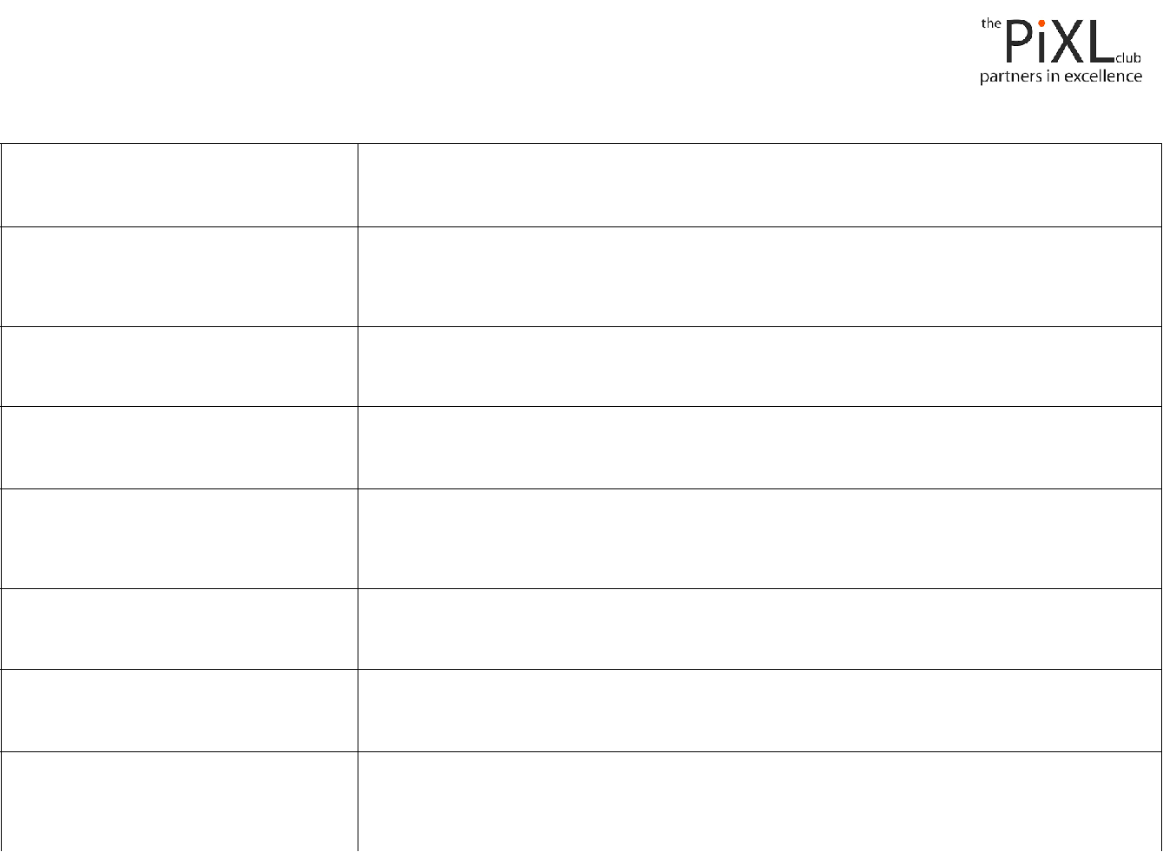

Fractional distillation

Exothermic reaction

Endothermic reaction

Alkali

Acid

Base

Oxidation

Reduction

Chemistry topic 1 – Electronic structure, how electrons are arranged around the nucleus

A periodic table can give you the proton / atomic number of an element, this also tells you how many electrons are in the atom.

You will have used the rule of electrons shell filling, where:

The first shell holds up to 2 electrons, the second up to 8, the third up to 8 and the fourth up to 18 (or you may have been told 8).
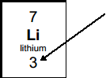

Atomic number =3, electrons = 3, arrangement 2 in the first shell and 1 in the second or

Li = 2,1

At A level you will learn that the electron structure is more complex than this, and can be used to explain a lot of the chemical properties of elements.

The ‘shells’ can be broken down into ‘orbitals’, which are given letters:’s’ orbitals, ‘p’ orbitals and ‘d’ orbitals.

Chemistry topic 2 – Oxidation and reduction

At GCSE you know that oxidation is adding oxygen to an atom or molecule and that reduction is removing oxygen, or that oxidation is removing hydrogen and reduction is

adding hydrogen. You may have also learned that oxidation is removing electrons and reduction is adding electrons.

At A level we use the idea of oxidation number a lot!

You know that the metals in group 1 react to form ions that are +1, i.e. Na⁺ and that group 7, the halogens, form -1 ions, i.e. Br -.

We say that sodium, when it has reacted has an oxidation number of +1 and that bromide has an oxidation number of -1.

All atoms that are involved in a reaction can be given an oxidation number.

An element, Na or O2 is always given an oxidation state of zero (0), any element that has reacted has an oxidation state of + or -.

As removing electrons is reduction, if, in a reaction the element becomes more negative it has been reduced, if it becomes more positive it has been oxidised.

-5 0 +5

You can read about the rules for assigning oxidation numbers here:

http://www.dummies.com/how-to/content/rules-for-assigning-oxidation-numbers-to-elements.html

Elements that you expect to have a specific oxidation state actually have different states, so for example you would expect chlorine to be -1, it can have many oxidation states: NaClO, in this compound it has an oxidation state of +1

There are a few simple rules to remember:

Metals have a + oxidation state when they react.

Oxygen is ‘king’ it always has an oxidation state of -2

Hydrogen has an oxidation state of +1 (except metal hydrides)

The charges in a molecule must cancel.

Examples: Sodium nitrate, NaNO3 |  |  | sulfate ion, SO4²⁻
 | Na +1 | 3x O²⁻ | 4xO²⁻ | and 2- charges ‘showing’
 | +1 | -6 | -8 | -2
To cancel: | N=+5 |  | S=+6

Q2.1 Work out the oxidation state of the underlined atom in the following:

a) MgCO3 |  |  |  | b) SO3 |  |  |  | c) NaClO3 |  |  |  |  | d) MnO2 |  |  | e) Fe2O3 |  |  | f) V2O5
g) KMnO4 |  |  |  | h) Cr2O7²⁻ |  |  |  | i) Cl2O4

Chemistry topic 3 – Isotopes and mass

You will remember that an isotopes are elements that have differing numbers of neutrons. Hydrogen has 3 isotopes;
Isotopes occur naturally, so in a sample of an element you will have a mixture of these isotopes. We can accurately measure the amount of an isotope using a mass spectrometer. You will need to understand what a mass spectrometer is and how it works at A level. You can read about a mass spectrometer here:

http://bit.ly/pixlchem3 http://www.kore.co.uk/tutorial.htm http://bit.ly/pixlchem4

http://filestore.aqa.org.uk/resources/chemistry/AQA-7404-
7405-TN-MASS-SPECTROMETRY.PDF

Q3.1 What must happen to the atoms before they are accelerated in the mass spectrometer?

Q3.2 Explain why the different isotopes travel at different speeds in a mass spectrometer.

A mass spectrum for the element chlorine will give a spectrum like this:
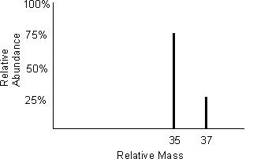

75% of the sample consist of chlorine-35, and 25% of the sample is chlorine-37.

Given a sample of naturally occurring chlorine ¾ of it will be Cl-35 and ¼ of it is Cl-37. We can calculate what the mean mass of the sample will be:

Mean mass = 75 x 35 + 25 x 37 = 35.5

100 100

If you look at a periodic table this is why chlorine has an atomic mass of 35.5.

http://www.avogadro.co.uk/definitions/ar.htm

An A level periodic table has the masses of elements recorded much more accurately than at GCSE. Most elements have isotopes and these have been recorded using mass spectrometers.

GCSE A level
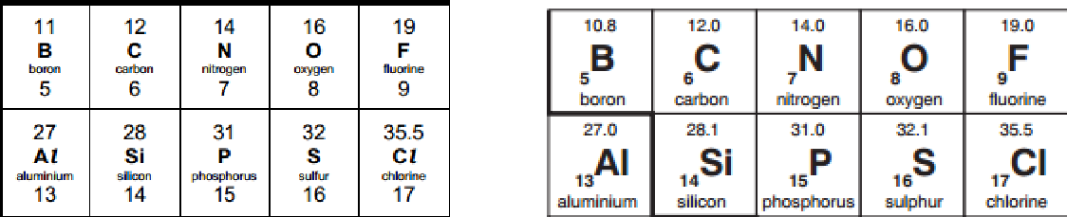

Given the percentage of each isotope you can calculate the mean mass which is the accurate atomic mass for that element.

Q3.3 Use the percentages of each isotope to calculate the accurate atomic mass of the following elements.

- Antimony has 2 isotopes: Sb-121 57.25% and Sb-123 42.75%

- Gallium has 2 isotopes: Ga-69 60.2% and Ga-71 39.8%

- Silver has 2 isotopes: Ag-107 51.35% and Ag-109 48.65%

- Thallium has 2 isotopes: Tl-203 29.5% and Tl-205 70.5%

- Strontium has 4 isotopes: Sr-84 0.56%, Sr-86 9.86%, Sr-87 7.02% and Sr-88 82.56%

TASK 2: Complete Pre-Knowledge Topics 4 to 10
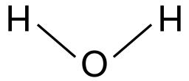
Chemistry topic 4 – The shapes of molecules and bonding.

Have you ever wondered why your teacher drew a water molecule like this?

The lines represent a covalent bond, but why draw them at an unusual angle?

If you are unsure about covalent bonding, read about it here:

http://bit.ly/pixlchem5

http://www.chemguide.co.uk/atoms/bonding/covalent.html#top

At A level you are also expected to know how molecules have certain shapes and why they are the shape they are.

You can read about shapes of molecules here:

http://bit.ly/pixlchem6

http://www.chemguide.co.uk/atoms/bonding/shapes.html#top

Q4.1 Draw a dot and cross diagram to show the bonding in a molecule of aluminium chloride (AlCl3)

Q4.2 Draw a dot and cross diagram to show the bonding in a molecule of ammonia (NH3)

Q4.3 What is the shape and the bond angles in a molecule of methane (CH4)?

Chemistry topic 5 – Chemical equations

Balancing chemical equations is the stepping stone to using equations to calculate masses in chemistry.

There are loads of websites that give ways of balancing equations and lots of exercises in balancing.

Some of the equations to balance may involve strange chemical, don’t worry about that, the key idea is to get balancing right.

http://bit.ly/pixlchem7

http://www.chemteam.info/Equations/Balance-Equation.html

This website has a download; it is safe to do so:

http://bit.ly/pixlchem8

https://phet.colorado.edu/en/simulation/balancing-chemical-equations

Q5.1 Balance the following equations

- H2 + 02 → H20

- S8+ 02→ S03

c. HgO → Hg+ 02
d. Zn+ HCl→ | ZnCl2+ H2
e. Na+ H20 → | NaOH + H2
f. C10H16+ CI2 → C + HCl
g. Fe+ 02→ | Fe203
h. C6H1206+ 02→ C02+ H20
i. Fe203 + H2 → Fe + H20
j. Al + FeO → Al2O3 + Fe

Chemistry topic 6 – Measuring chemicals – the mole

From this point on you need to be using an A level periodic table, not a GCSE one you can view one here:

http://bit.ly/pixlpertab

https://secondaryscience4all.files.wordpress.com/2014/08/filestore_aqa_org_uk_subjects_aqa-2420-w-trb-ptds_pdf.png

Now that we have our chemical equations balanced, we need to be able to use them in order to work out masses of chemicals we need or we can produce.

The mole is the chemists equivalent of a dozen, atoms are so small that we cannot count them out individually, we weigh out chemicals.

For example:

magnesium + sulfur → magnesium sulfide

Mg

+ S

→

MgS

We can see that one atom of magnesium will react with one atom of sulfur, if we had to weigh out the atoms we need to know how heavy each atom is.

From the periodic table: Mg = 24.3 and S = 32.1

If I weigh out exactly 24.3g of magnesium this will be 1 mole of magnesium, if we counted how many atoms were present in this mass it would be a huge number (6.02 x 10²³!!!!), if I weigh out 32.1g of sulfur then I would have 1 mole of sulfur atoms.

So 24.3g of Mg will react precisely with 32.1g of sulfur, and will make 56.4g of magnesium sulfide.

Here is a comprehensive page on measuring moles, there are a number of descriptions, videos and practice problems.

You will find the first 6 tutorials of most use here, and problem sets 1 to 3.

http://bit.ly/pixlchem9

http://www.chemteam.info/Mole/Mole.html

Q6.1 Answer the following questions on moles.

- How many moles of phosphorus pentoxide (P4O10) are in 85.2g?

- How many moles of potassium in 73.56g of potassium chlorate (V) (KClO3)?

- How many moles of water are in 249.6g of hydrated copper sulfate(VI) (CuSO4.5H2O)? For this one, you need to be aware the dot followed by 5H2O means that the molecule comes with 5 water molecules so these have to be counted in as part of the molecules mass.

- What is the mass of 0.125 moles of tin sulfate (SnSO4)?

- If I have 2.4g of magnesium, how many g of oxygen(O2) will I need to react completely with the magnesium? 2Mg +O2 → MgO

Chemistry topic 7 – Solutions and concentrations

In chemistry a lot of the reactions we carry out involve mixing solutions rather than solids, gases or liquids.

You will have used bottles of acids in science that have labels saying ‘Hydrochloric acid 1M’, this is a solution of hydrochloric acid where 1 mole of HCl, hydrogen chloride (a gas) has been dissolved in 1dm³ of water.

The dm³ is a cubic decimetre, it is actually 1 litre, but from this point on as an A level chemist you will use the dm³ as your volume measurement.

http://bit.ly/pixlchem10

http://www.docbrown.info/page04/4_73calcs11msc.htm

Q7.1

- What is the concentration (in mol dm⁻³) of 9.53g of magnesium chloride (MgCl2) dissolved in 100cm³ of water?

- What is the concentration (in mol dm⁻³) of 13.248g of lead nitrate (Pb(NO3)2) dissolved in 2dm³ of water?

- If I add 100cm³ of 1.00 mol dm³ HCl to 1.9dm³ of water, what is the molarity of the new solution?
- What mass of silver is present in 100cm³ of 1moldm⁻³ silver nitrate (AgNO3)?

- The Dead Sea, between Jordan and Israel, contains 0.0526 moldm⁻³ of Bromide ions (Br ⁻), what mass of bromine is in 1dm³ of Dead Sea water?

Chemistry topic 8 – Titrations

One key skill in A level chemistry is the ability to carry out accurate titrations, you may well have carried out a titration at GCSE, at A level you will have to carry them out very precisely and be able to describe in detail how to carry out a titration - there will be questions on the exam paper about how to carry out practical procedures.

You can read about how to carry out a titration here, the next page in the series (page 5) describes how to work out the concentration of the unknown.

http://bit.ly/pixlchem11

http://www.bbc.co.uk/schools/gcsebitesize/science/triple_aqa/further_analysis/analysing_substances/revisio n/4/

Remember for any titration calculation you need to have a balanced symbol equation; this will tell you the ratio in which the chemicals react.

E.g. a titration of an unknown sample of sulfuric acid with sodium hydroxide.

A 25.00cm³ sample of the unknown sulfuric acid was titrated with 0.100moldm⁻³ sodium hydroxide and required exactly 27.40cm³ for neutralisation. What is the concentration of the sulfuric acid?

Step 1: the equation

2NaOH + H2SO4 → Na2SO4 + 2H2O

Step 2; the ratios

2 :

1
Step 3: how many moles of sodium hydroxide 27.40cm³ = 0.0274dm³

number of moles = c x v = 0.100 x 0.0274 = 0.00274 moles

step 4: Using the ratio, how many moles of sulfuric acid

for every 2 NaOH there are 1 H2SO4 so, we must have 0.00274/2 =0.00137 moles of H2SO4

Step 5: Calculate concentration. concentration = moles/volume ←in dm³ = 0.00137/0.025 = 0.0548 moldm⁻³

Here are some additional problems, which are harder, ignore the questions about colour changes of indicators.

http://bit.ly/pixlchem12

http://www.docbrown.info/page06/Mtestsnotes/ExtraVolCalcs1.htm

Use the steps on the last page to help you

Q8.1 A solution of barium nitrate will react with a solution of sodium sulfate to produce a precipitate of barium sulfate.

Ba(NO3)2(aq) + Na2SO4(aq) → BaSO4(s) + 2NaNO3(aq)

What volume of 0.25moldm⁻³sodium sulfate solution would be needed to precipitate all of the barium from 12.5cm³ of 0.15 moldm⁻³ barium nitrate?

Chemistry topic 9 – Organic chemistry – functional groups

At GCSE you would have come across hydrocarbons such as alkanes (ethane etc) and alkenes (ethene etc). You may have come across molecules such as alcohols and carboxylic acids. At A level you will learn about a wide range of molecules that have had atoms added to the carbon chain. These are called functional groups, they give the molecule certain physical and chemical properties that can make them incredibly useful to us.

Here you are going to meet a selection of the functional groups, learn a little about their properties and how we give them logical names.

You will find a menu for organic compounds here:

http://bit.ly/pixlchem13

http://www.chemguide.co.uk/orgpropsmenu.html#top

And how to name organic compounds here:

http://bit.ly/pixlchem14

http://www.chemguide.co.uk/basicorg/conventions/names.html#top

Using the two links see if you can answer the following questions:

Q9.1 Halogenoalkanes
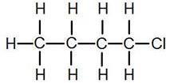

What is the name of this halogenoalkane?

How could you make it from butan-1-ol?

Q9.2 Alcohols

How could you make ethanol from ethene?

How does ethanol react with sodium, in what ways is this a) similar to the reaction with water, b) different to the reaction with water?

Q9.3 Aldehydes and ketones

Draw the structures of a) propanal b) propanone

How are these two functional groups different?

Chemistry topic 10 – Acids, bases, pH

At GCSE you will know that an acid can dissolve in water to produce H⁺ ions, at A level you will need a greater understanding of what an acid or a base is.

Read the following page and answer the questions

http://bit.ly/pixlchem15

http://www.chemguide.co.uk/physical/acidbaseeqia/theories.html#top

Q10.1 What is your new definition of what an acid is?

Q10.2 How does ammonia (NH3) act as a base?

http://bit.ly/pixlchem16

http://www.chemguide.co.uk/physical/acidbaseeqia/acids.html#top

Q10.3 Ethanoic acid (vinegar) is a weak acid, what does this mean?

Q10.4 What is the pH of a solution of 0.01 moldm⁻³ of the strong acid, hydrochloric acid?

