Biology at Sir Graham Balfour

Miss A Brinsdon - [ABrinsdon@sirgrahambalfour.staffs.sch.uk](mailto:ABrinsdon@sirgrahambalfour.staffs.sch.uk)

Welcome to A-Level Biology, we will be following the AQA A level Biology course.

Over the two years we will study the following topics;

* 3.1 Biological molecules
* 3.2 Cells
* 3.3 Organisms exchange substances with their environment
* 3.4 Genetic information, variation and relationships between organisms.
* 3.5 Energy transfers in and between organisms.
* 3.6 Organisms respond to changes in their internal and external environments.
* 3.7 Genetics, populations, evolution and ecosystems.
* 3.8 The control of gene expression.

|  |  |  |  |  |  |  |  |  |  |  |  |  |  |  |  |  |  |  |  |  |  |  |  |  |  |  |  |  |  |  |  |  |
| --- | --- | --- | --- | --- | --- | --- | --- | --- | --- | --- | --- | --- | --- | --- | --- | --- | --- | --- | --- | --- | --- | --- | --- | --- | --- | --- | --- | --- | --- | --- | --- | --- |
| To demonstrate your commitment to the course and to prepare you for September, you must complete the following tasks to the best of your ability. These tasks are compulsory and must be completed prior to your first Biology lesson in Year 12.  **Section A, to be completed by Friday 12th June 2020.**   |  |  |  |  | | --- | --- | --- | --- | | Task | Activity | Evidence to show | Complete? | | Section A |  | To be completed by 12/06/2020 |  | | 1 | Checking out a number of A level websites. | Outline of the content of each website. |  | | 2 | Download head start to Biology book. |  |  | | 3 | Head start book, 9 sections. | 1. Produce summary notes and revision cards for each section. 2. Produce either a deconstruct or a 5-10 point summary on the key points from each of the 9 sections. 3. The questions from each page need to be answered. **After completing each section self-assess your answers in green pen (alternative colour if you do not have a green pen) using page 34.** |  | | 4 | Websites to look at. | 1. Cornell notes from the video. 2. Mind map linking biological molecules to GCSE. |  | | 5 | Magnification and genetic questions | Answers to questions. |  | | 6 | Maths, websites and tests. | 1. Answers to the 5 sets of questions, additional research to help as necessary. 2. Answers to the 5 10 minute Math tests, marked and corrected as necessary. |  |   Task 1- Watch this for some advice; Make sure you do this as you move throughout the course. <https://www.youtube.com/watch?v=3kYCDdxGws4>  There are a number of websites to become familiar with, these are just a starting point;  <https://s-cool.co.uk/a-level/biology>  <http://biologymad.com/master.html?http://biologymad.com/frontpage.htm>  <http://www.biologyguide.net/>  <http://www.physicsandmathstutor.com/biology-revision/a-level-aqa/>  <https://learn.genetics.utah.edu/>  <https://www.zsl.org/conservation>  <http://www.dnaftb.org/>  **Task 2 – Download the CGP Head start to A-level Biology.**  This is free for you to download the kindle version, alternatively the hard copy is also available to buy.  Both the hard copy and kindle version are available through amazon:  <https://www.amazon.co.uk/Head-Start-level-Biology-Level/dp/1782942793/ref=sr_1_1?dchild=1&keywords=head+start+to+a+level+biology&qid=1585908389&sr=8-1>    **Task 3 – using the Head start to Biology text book.**  You need to read through the 9 sections.  Produce summary notes and revision cards for each section.  Then either a deconstruct or a 5-10 point summary on the key points from each of the 9 sections.  The questions from each page need to be answered. **After completing each section self-assess your answers in green pen (alternative colour if you do not have a green pen) using page 34.**  To help with section 6 haemoglobin and the Bohr effect this clip should help explain it further; <https://www.youtube.com/watch?v=wgSUdxrlO8Y> |

**Task 4; Cornell note taking and 5 questions.**

Read the information on these websites on Biological molecules and enzymes to give you a back ground understanding.

* <https://www.s-cool.co.uk/a-level/biology/biological-molecules-and-enzymes>
* <https://www.bbc.com/education/guides/z8wsgk7/revision/1>

You need to have a go at making Cornell notes from these videos, if you are unsure of how to take Cornell notes watch this <https://www.youtube.com/watch?v=WtW9IyE04OQ> )

Once you have made your Cornell notes I would also like you to, producing a linking mind map to show where you can link Biological molecules into the area you have covered in GCSE Biology. <https://www.youtube.com/watch?v=H8WJ2KENlK0>

<http://ed.ted.com/lessons/activation-energy-kickstarting-chemical-reactions-vance-kite>

**Task 5;** Answer the following questions from GCSE; If you are unsure of any of the answers you must use your GCSE revision guide to help you.

1. A student views the image of a cell magnified 40 000 times. The image is 50 mm long. Calculate the actual length of the sample in micrometres.
2. A sperm cell has a tail 40 µm long and a student draws it 40 mm long. Calculate the magnification.
3. A red blood cell is 7.5 µm in diameter. It is magnified 2000 times. Calculate the diameter of the image seen through the microscope in millimetres.
4. In pea plants, seed texture (round or wrinkled) is passed from parent to offspring by monohybrid inheritance. The allele for round seed is represented by R and the allele for wrinkled seeds is represented by r. Draw a genetic diagram to show the possible genotypes of the offspring produces by crossing a homozygous round seed pea plant with a homozygous wrinkled seed plant.
5. In merpeople, the dominant allele, T, causes a long tail and the recessive allele, t, causes a short tail. Using a Punnet square, predict the ratio of long to short tailed merbabies for a cross between a heterozygous merman and a mermaid who is homozygous recessive for tail length.

**Task 6;** Maths skills are important in A level Biology and account for at least 10% of the overall papers. It is important you practice these skills.

**Below is a link to all the Maths skills you are expected to use in Biology.**

<https://www.aqa.org.uk/subjects/science/as-and-a-level/biology-7401-7402/mathematical-requirements-and-exemplifications>

Complete the questions below.

If you need to recap any maths skills the link below will help, there are Power points on each section for you to use as necessary.

<https://www.aqa.org.uk/resources/science/as-and-a-level/teach/maths-skills-briefings>

You must hand in the answers to the following areas;

1. Indices
2. Units
3. Standard form
4. Ratio
5. Plotting equations.

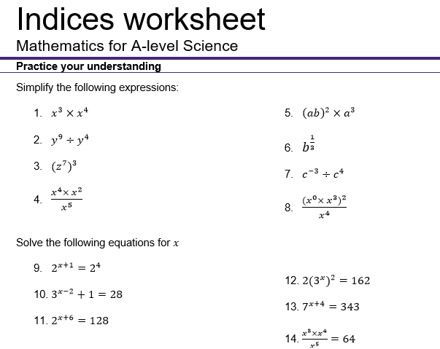

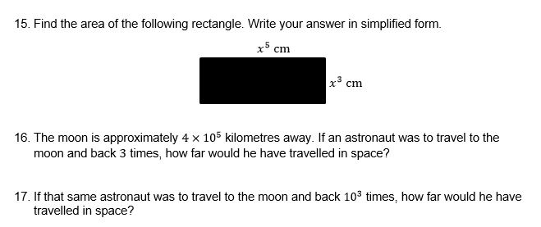

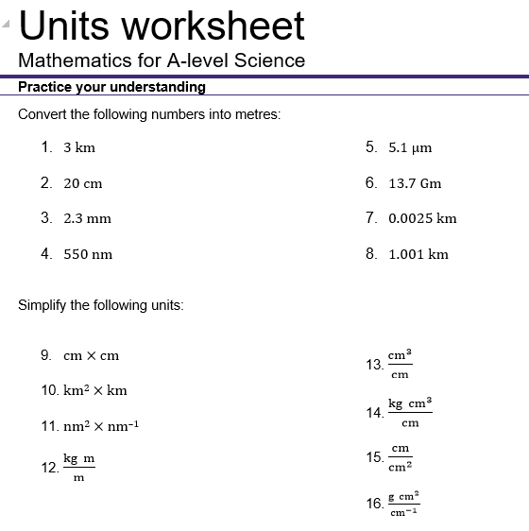

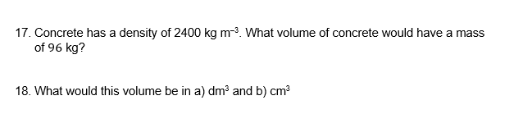

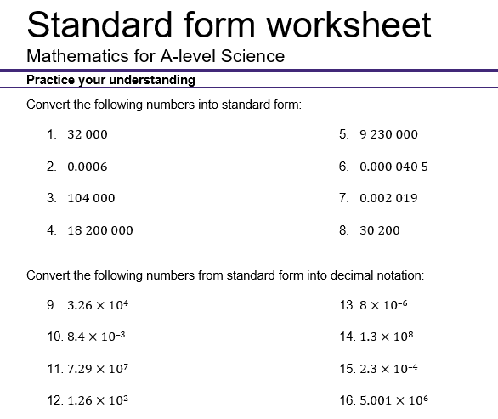

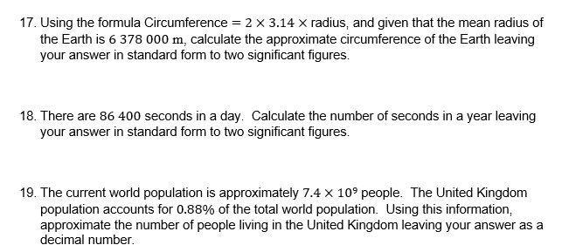

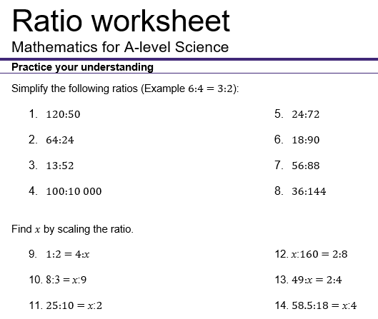

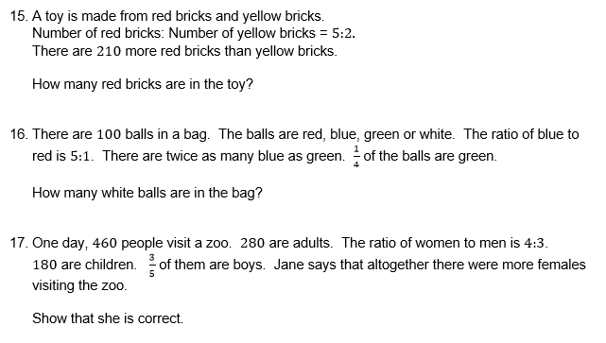

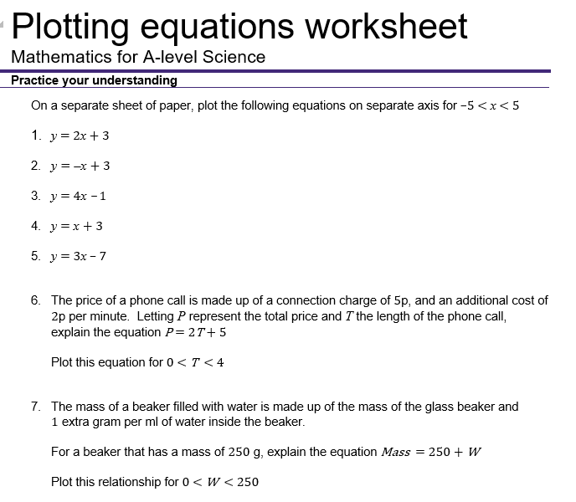

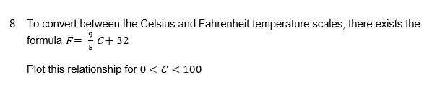

Complete the biological maths questions below. Try to keep to 10 minutes per test.

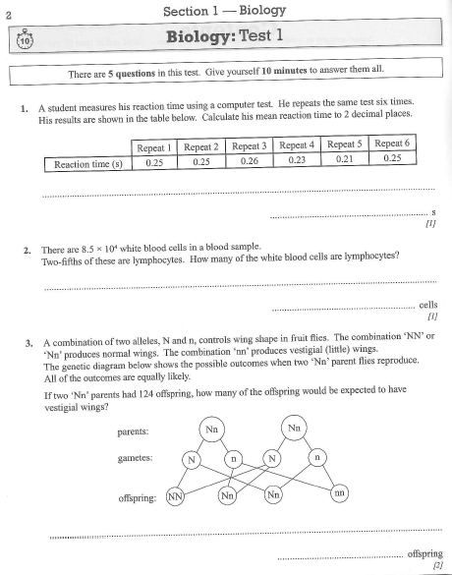

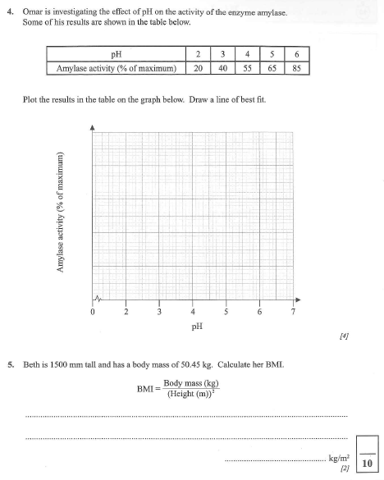

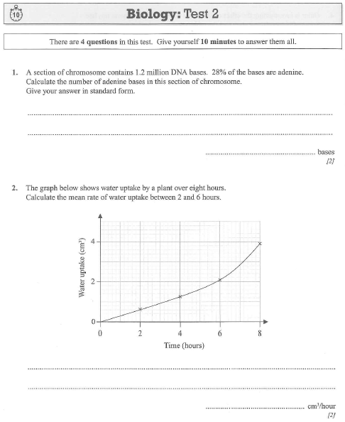

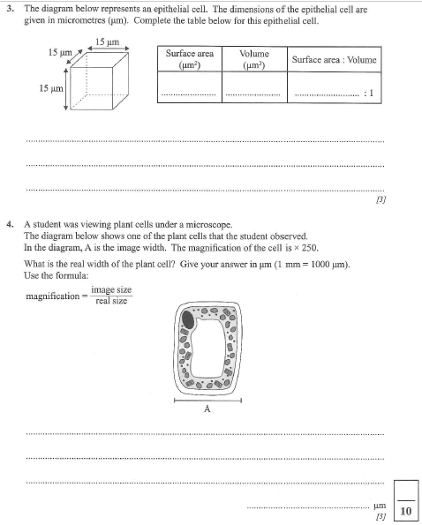

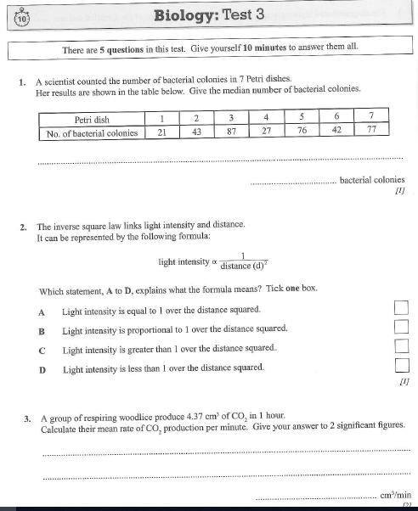

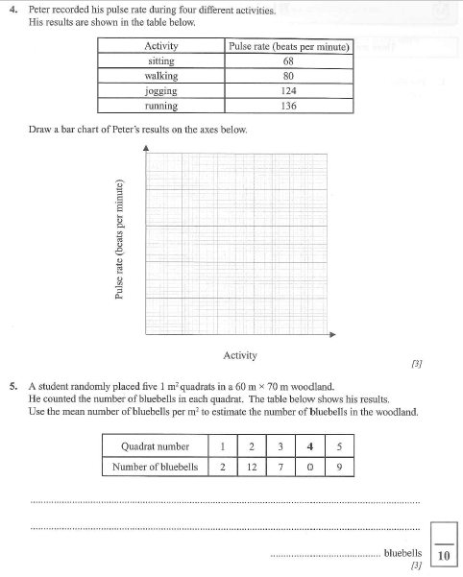

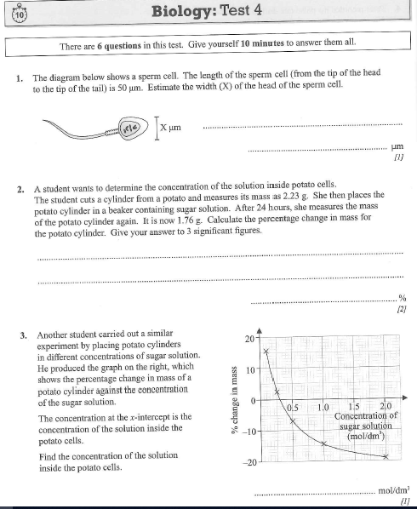

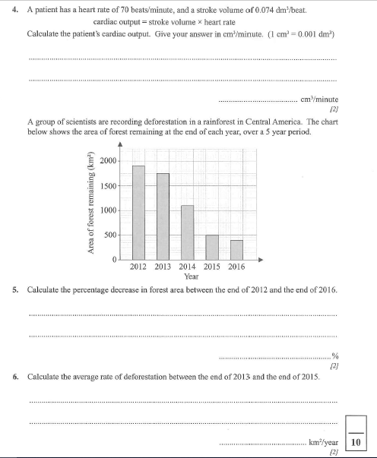

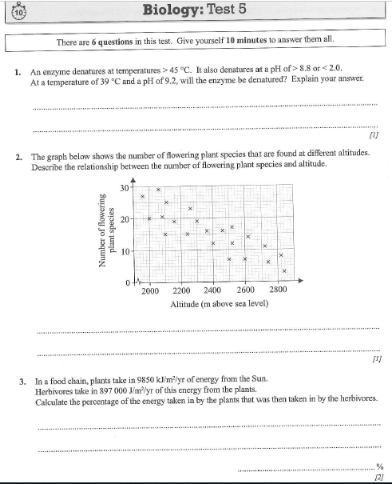

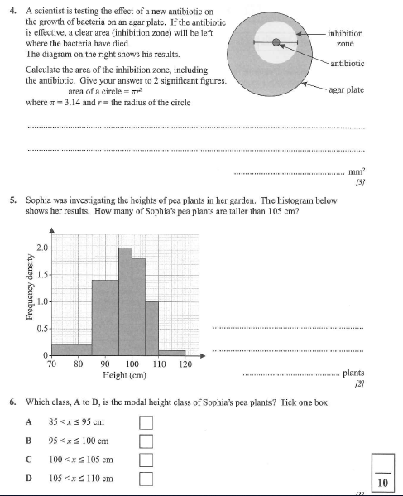

**Maths section answers. Any question involving measurements may have incorrect answer due to scale changes. E.g. test 2 question 4.**

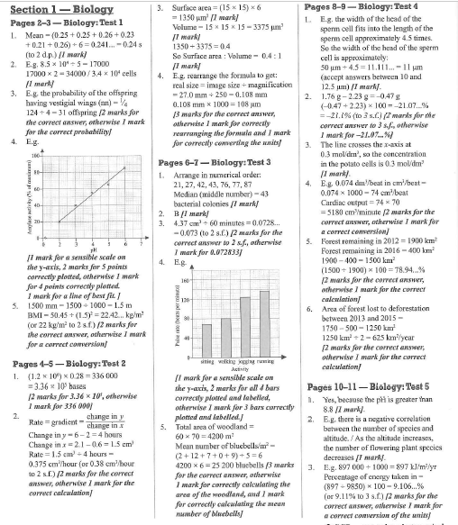

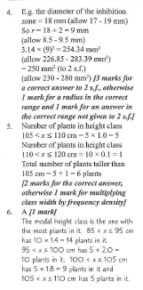

**Section B, to be completed by Friday 10th July.**

|  |  |  |  |
| --- | --- | --- | --- |
| Task | Activity | Evidence to show | Complete? |
| 7 | Key concept summary.  Word glossary to be completed throughout Section B. The words for each section follow on from the definitions.  GCSE Pod transition summary. | Completed glossary.  Workbook 1 activities. |  |
| 8 | Seneca assignment, pre-reading and notes. | Completed Seneca assignment and notes to review at a later date. |  |
| 9 | Label animal cell. | Completed diagram. |  |
| 10 | 1. Watch the video surprised you from watching this? 2. Then research the function of the following organelles;   Cell-surface membrane, nucleus, mitochondrion, golgi apparatus, golgi vesicle, lysosome, ribosome, rough endoplasmic reticulum and smooth endoplasmic reticulum.   1. For each organelle from the above list and write a sentence explaining why each is important in the cell. | 1. What surprised you from watching this? 2. Functions of the cell organelles. 3. 10 sentences explaining why each organelle is important. |  |
| 11 | 1. Complete the Seneca pre reading and summary notes from Biological molecules. 2. Create a flow diagram or mind map. | 1. Pre-reading notes to review later. 2. Flow diagram, needs to include diagram. |  |
| 12 | Enzymes. | Write a letter to a GP or a sufferer to explain what an enzyme is. You need to include:  The structure of an enzyme  An explanation on what enzymes do inside the body  Suggest why this could effect the nervous system. |  |
|  | Transition questions. | Answers to questions, currently in booklet for students to self-mark. |  |

Task 7; visit <https://members.gcsepod.com/shared/podcasts/title/13635/81931>

Watch the GCSE pods to review content. Complete workbook 1 tasks.

These are the key words from topic 1, you need to write the word against the definition.

**Biological Molecules**

|  |  |  |
| --- | --- | --- |
| 1 |  | Type of chemical bond in which two atoms share a pair of electrons. |
| 2 |  | A bond between a positive ion which has lost an electron(s) and a negative ion which has gained an electron(s). |
| 3 |  | Chemical bond formed between the positive charge on a hydrogen atom and the negative charge on another atom of an adjacent molecule e.g. between the Hydrogen atom of one water molecule and the Oxygen atom of an adjacent water molecule |
| 4 |  | A molecule which has a partially positive charge in one part of the molecule and completely negative charge in another part (a dipole). |
| 5 |  | One of many small molecules that combine together to form a polymer |
| 6 |  | Large molecule made up of many repeating smaller molecules (monomers). |
| 7 |  | The process of making a polymer |
| 8 |  | Chemical process in which two molecules combine to form a more complex one with the elimination of a simple substance, usually water. Many biological polymers (e.g. polysaccharides, polypeptides) are formed by condensation. |
| 9 |  | The breaking down of large molecules into smaller ones by the addition of water molecules. |
| 10 |  | All the chemical processes that take place in living organisms. |
| 11 |  | The mass of a substance containing the same number of fundamental units as there are atoms in exactly 12g of 12C. |
| 12 |  | An aqueous solution that contains 1 mole of solute in 1 litre of solution. |
| 13 |  | Compounds made from carbon, hydrogen and oxygen. Either monosaccharides, disaccharides and polysaccharides. |
| 14 |  | A single sugar e.g. glucose |
| 15 |  | Molecules containing carbon that can be found in living things; four classes are carbohydrates, proteins (chain of amino acids), lipids, and nucleic acids |
| 16 |  | Made up of two sugar units that are formed by a condensation reaction. Monosaccharides are joined by a glycosidic bond. |
| 17 |  | Made of many sugar units that are formed by a condensation reaction. Monosaccharides are joined by a glycosidic bond. |
| 18 |  | A sugar made up of 6 carbons. |
| 19 |  | C6H12O6 – a single sugar which is used in respiration. |
| 20 |  | A sugar that serves as a reducing agent. All monosaccharides are reducing sugars along with some disaccharides. |
| 21 |  | Heat solution with Benedict’s reagent to test for reducing sugars. If it goes brick red then a reducing sugar is present. |
| 22 |  | Blue solution which is used to test for reducing and non-reducing sugars. |
| 23 |  | Bond between sugar molecules in disaccharides and polysaccharides. |
| 24 |  | A sugar which cannot serve as a reducing agent. An example is sucrose. |
| 25 |  | Following a negative reducing sugars test. Heat the solution with HCl to hydrolyse the non-reducing sugar into it’s monosaccharides. Then perform the Benedict’s test again. If you get a positive result after hydrolysis then a non-reducing sugar is present. |
| 26 |  | A polysaccharide found in plant cells made up of alpha-glucose – comprised of amylose (alpha-1,4 glyosidic bonds) and amylopectin (alpha-1,4- and alpha-1,6-glyosidic bonds). |
| 27 |  | A highly branched polysaccharide made up of alpha-glucose found in animal cells (alpha-1,4- and alpha-1,6-glyosidic bonds). |
| 28 |  | A polysaccharide made up of beta-glucose found in plant cells (beta-1,4-glycosidic bonds). |
| 29 |  | An isomer of glucose that can bond together to form starch or glycogen. |
| 30 |  | An isomer of glucose that can bond together to form cellulose. |
| 31 |  | A class of organic compounds that are fatty acids are their derivatives and are insoluble in water but soluble in organic solvents. They include triglycerides, phospholipids, waxes and steroids. |
| 32 |  | An individual lipid molecule made up of a glycerol molecule and three fatty acids. Contains ester bonds. |
| 33 |  | A carboxylic acid with a hydrocarbon tail. |
| 34 |  | A molecule which combines with three fatty acids to form triglycerides. It is 3 carbon chain with 3 hydroxyl groups. |
| 35 |  | A fatty acid in which there are no double bonds between the carbon atoms |
| 36 |  | Fatty acid which possesses a carbon chain with a single double bond between carbon atoms. |
| 37 |  | Fatty acid which possesses a carbon chain with many double bonds between carbon atoms. |
| 38 |  | Triglyceride in which one of the three fatty acid molecules is replaced by a phosphate molecule. Phospholipids are important in the structure an functioning of plasma membranes. |
| 39 |  | Section of a molecule which is attracted to water. |
| 40 |  | Section of a molecule which is repulsed by water. |
| 41 |  | Test for lipids. Mix your sample with ethanol and then add water. If a white cloudy emulsion forms then a lipid is present. |
| 42 |  | A polymer which is made up of amino acids linked by peptide bonds. May also contain prosthetic groups as part of its quaternary structure. |
| 43 |  | A monomer which makes up proteins. Has a central carbon atom which is bonded to: a carboxylic acid group, an amino group, a hydrogen atom and a R group. |
| 44 |  | The -NH2 group of an amino acid. |
| 45 |  | The -COOH group of an amino acid. |
| 46 |  | Each of the 20 amino acids has a different R group – determines the bonding that the amino acid can carry out. |
| 47 |  | The type of bond that is formed between two amino acids. |
| 48 |  | Many amino acids joined together by peptide bonds. |
| 49 |  | The sequence of amino acids that makes up the polypeptides of a protein. |
| 50 |  | The way in which the chain of amino acids of the polypeptides of a protein is folded. |
| 51 |  | The folding of a whole polypeptide chain in a precise way, as determined by the amino acids of which it is composed. |
| 52 |  | Bond formed between Sulphur atoms in R groups of amino acids. |
| 53 |  | A number of polypeptide chains linked together, and sometimes associated with non-protein groups to form a protein. |
| 54 |  | A simple biochemical reaction to detect the presence of protein, if the Biuret’s solution turns purple then protein is present. |

|  |  |  |  |
| --- | --- | --- | --- |
| Condensation | Covalent Bond | Polar Molecule | Molar (M) Solution |
| Cellulose | Non-reducing sugar test | Starch | Saturated fatty acid |
| Hydrolysis | Ionic Bond | Monomer | Carbohydrate |
| Metabolism | Hydrogen Bond | Polymer | Monosaccharide |
| Amino acid | Polypeptide | Amino group | Poly-unsaturated fatty acid |
| Mole | Hexose sugar | Polymerisation | Non-reducing sugar |
| Organic Molecule | Glucose | Beta glucose | Reducing sugar test |
| Mono-unsaturated fatty acid | Hydrophilic | Lipid | Benedict’s reagent |
| Disaccharide | Triglyceride | Glycosidic bond | Reducing Sugar |
| Polysaccharide | Fatty acid | Glycogen | Secondary protein structure |
| Alpha glucose | Glycerol | Hydrophobic | Biuret test |
| Primary protein structure | Tertiary protein structure | Quaternary protein structure | Phospholipid |
| Peptide bond | Carboxyl group | Disulfide bridge | R-group |
| Emulsion test | Protein |

**Enzymes**

|  |  |  |
| --- | --- | --- |
| 55 |  | A protein that acts as a catalyst and so lowers the activation energy needed for a reaction. |
| 56 |  | Energy required to bring about a reaction. |
| 57 |  | A group of amino acids that makes up the region of an enzyme into which the substrate fits in order to catalyse a reaction. |
| 58 |  | A substance that is acted on or used by another substance or process. Fits into the active site of an enzyme. |
| 59 |  | The intermediate formed when a substrate molecule interacts with the active site of an enzyme. |
| 60 |  | Describes the relationship between the active site of an enzyme and the substrate molecule – the way in which they fit together. |
| 61 |  | Describes how enzymes catalyse a certain chemical reaction. |
| 62 |  | A mechanism of interaction between an enzyme and a substrate. As the substrate fits into the active site the active site of the enzyme changes shape in order to allow an enzyme-substrate complex to be formed. |
| 63 |  | An analogy for how enzymes work – only the correctly sized key (substrate) fits into the key hole (active site) of the lock (enzyme) |
| 64 |  | The speed of a chemical reaction - can be worked out by looking at the decrease in concentration of a reactant over time or increase in concentration of a product over time. |
| 65 |  | The energy of motion, observable as the movement of an object, particle or set of partices. |
| 66 |  | A figure expressing the acidity or alkalinity of a solution on a logarithmic scale on which 7 is neutral, lower values are more acidic and higher values are more alkaline. Equivalent to -log10[H+]. |
| 67 |  | A substance which reduces the activity of an enzyme. |
| 68 |  | A form of inhibitor which binds to the active site of the enzyme preventing the binding of substrate. |
| 69 |  | A form of inhibitor which does **not** bind at the active site of the enzyme which prevents the binding of substrate. |

|  |  |  |  |
| --- | --- | --- | --- |
| Enzyme-substrate complex | Lock and key | Inhibitor | Enzyme |
| Complimentary | Rate of reaction | Competitive inhibitor | Activation energy |
| Specific | Kinetic Energy | Non-competitive inhibitor | Active Site |
| Induced fit | pH | Substrate |

**Nucleic Acids**

|  |  |  |
| --- | --- | --- |
| 70 |  | Deoxyribonucleic acid which is present in nearly all living organisms as the carrier of genetic information. A double helix made up of two polynucleotide chains, running **antiparallel** to each other, with the sugar-phosphate backbone on the outside and organic bases bonded together by Hydrogen bonds in the centre of the helix. The nucleotides have a deoxyribose sugar and the bases adenine, thymine, guanine or cytosine. |
| 71 |  | Complex chemicals made up of an organic base, a sugar and a phosphate. They are the basic units of which the nucleic acids DNA and RNA are made. |
| 72 |  | A polymer of monomers called nucleotides. |
| 73 |  | The bond formed by a condensation reaction between the phosphate group of one nucleotide and the pentose sugar of another nucleotide. |
| 74 |  | Part of a nucleotide - either adenine, thymine, cytosine, guanine or uracil. |
| 75 |  | A polynucleotide which contains nucleotides that have the pentose sugar **ribose** rather than deoxyribose and contains the bases adenine, uracil, guanine or cytosine. Can be either mRNA, tRNA or rRNA. |
| 76 |  | Specific rules for how the bases pair together. Adenine pairs with thymine with 2 hydrogen bonds. Guanine binds with cytosine with 3 hydrogen bonds. |
| 77 |  | Structure of DNA made up of 2 strands of nucleotides running in opposite directions. |
| 78 |  | The process in which the double helix of a DNA molecule unwinds and each strand acts as a template on which a new strand is constructed. |
| 79 |  | Enzyme that acts on a specific region of the DNA molecule to break the hydrogen bonds between the bases causing the two strands to separate and expose the nucleotide bases in that region |
| 80 |  | Enzyme that joins DNA nucleotides together in a condensation reaction (forming phosphodiester bonds) during DNA replication. |
| 81 |  | An activated nucleotide found in all living organisms, which is produced during respiration and acts as an energy carrier. The hydrolysis of ATP (catalyzed by ATP hydrolase) leads to the formation of adenosine diphosphate (ADP) and inorganic phosphate, with the release of energy. |
| 82 |  | A nucleotide which combines in a condensation reaction, catalysed by ATP synthase, with a phosphate molecule to form ATP. |
| 83 |  | An enzyme which catalyses the formation of ATP. |
| 84 |  | An enzyme which catalyses the hydrolysis of ATP. |
| 85 |  | Group of enzymes that catalyse the formation of polymers from monomers |

|  |  |  |  |
| --- | --- | --- | --- |
| Phosphodiester bond | Organic base | DNA polymerase | ATP Synthase |
| Nucleotide | ADP | RNA | ATP Hydrolase |
| Polynucleotide | Complimentary base pairing | Polymerases | Double helix |
| DNA | ATP (Adenosine triphosphate) | Semiconservative replication | DNA helicase |

**Water & Inorganic Ions**

|  |  |  |
| --- | --- | --- |
| 86 |  | The amount of energy needed to change the temperature of 1kg of the substance by 1℃. |
| 87 |  | The heat energy needed to change the substance from a liquid at its boiling point into gas at the same temperature. |
| 88 |  | Attraction between molecules of the same type. It is important in the movement of water up a plant. |
| 89 |  | The tension of the surface film of a liquid caused by the attraction of the particles in the surface layer by the bulk of the liquid. |
| 90 |  | The liquid in which a solute is dissolved to form a solution. |
| 91 |  | Formed when an element or compound, that does not contain carbon, gains or looses electrons to become negatively or positively charged, for example: hydrogen ions, phosphate ions, iron ions and sodium ions. |
| 92 |  | A material that allows light to pass through so that objects behind can be distinctly seen. |

|  |  |  |  |
| --- | --- | --- | --- |
| Cohesion | Inorganic ions | Specific heat capacity | Solvent |
| Surface tension | Transparent | Latent heat of Vaporisation |

Task 8.

Pre-reading. Using Seneca. Complete the assignment and produce a set of summary notes to review later.

For those of you who have not used Seneca before here is a short video outlining how to.

<https://www.loom.com/share/4a9f4be4e7a543278747a8de0c095d2b>

Otherwise, here is your class code for these transition activities. Go through the link on google chrome.

<https://app.senecalearning.com/dashboard/join-class/5aqsf73qgj>

You have an assignment set from the cells section to complete before you attempt the next tasks.

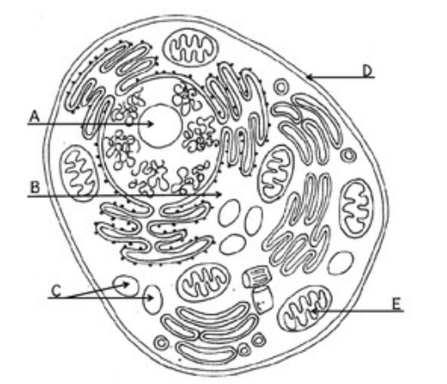Task 9: Label the following organelles on this diagram. You will need to add on some more label lines.

Mitochondrion

Nucleolus

Smooth Endoplasmic Reticulum

Vesicle

Rough Endoplasmic Reticulum

Cell Membrane

Lysosomes

Ribosome

**Task 10**;

1. Watch this (if the link does not work, on YouTube search secret universe hidden life of the cell BBC). <https://www.bing.com/videos/search?q=yotube+secret-universe-the-hidden-life-of-the-cell&docid=607995990974006026&mid=47E3C4C1E990AFAA4DB447E3C4C1E990AFAA4DB4&view=detail&FORM=VIRE> What has surprised you from watching this?
2. Then research the function of the following organelles;

Cell-surface membrane, nucleus, mitochondrion, golgi apparatus, golgi vesicle, lysosome, ribosome, rough endoplasmic reticulum and smooth endoplasmic reticulum.

1. For each organelle from the above list and write a sentence explaining why each is important in the cell.

**Task 11;**

* Biological molecules are often polymers and are based on a small number of chemical elements. In living organisms carbohydrates, proteins, lipids, inorganic ions and water all have important roles and functions related to their properties.
* DNA determines the structure of proteins, including enzymes. Enzymes catalyse the reactions that determine structures and functions from cellular to whole-organism level. Enzymes are proteins with a mechanism of action and other properties determined by their tertiary structure. ATP provides the immediate source of energy for biological processes.

1. Complete the Seneca pre reading and summary notes from Biological molecules.
2. Create a flow diagram or mind map to identify the different types of biological molecules and how they link together. You will need to include diagrams to show the final molecule and it should be done on an A3 piece of plain paper if possible.

The format how you present your flow chart or mind map and which questions you may want to include is up to you, some examples are given below (I expect you all to be able to do much better!!)

You must include the following molecules:

**Carbohydrates** – monosaccharides and poly saccharides

**Proteins** – primary, secondary and tertiary structure

**Lipids** – saturated/unsaturated.





**Task 12;** Krabbe disease occurs when a person doesn’t have a certain enzyme in their body. The disease effects the nervous system. Write a letter to a GP or a sufferer to explain what an enzyme is. You need to include:

The structure of an enzyme

An explanation on what enzymes do inside the body

Suggest why this could effect the nervous system.

Exam style questions.

The following 40 minute test is designed to test your recall, analysis and evaluative skills and knowledge.

Remember to use your exam technique: look at the command words and the number of marks each question is worth.

A suggested mark scheme is provided for you to check your answers.

1. a) What are the four base pairs found in DNA?

b) What does DNA code for?

c) Which organelle in a cell carries out protein synthesis?

2. a) What theory did Charles Darwin propose?

b) Why did many people not believe Darwin at the time?

c) Describe how fossils are formed. (3)

d) The fossil record shows us that there have been some species that have formed and some that have become extinct.

i) What is meant by the term ‘species’? (2)

ii) Describe how a new species may arise: (5)

3. Ecologists regularly study habitats to measure the species present and the effect of any changes.

One team of ecologists investigated the habitat shown in the picture below:



a) Define the following keywords:

i) Population

ii) Community

b) Give an example of one biotic factor and one abiotic factor that would be present in this habitat (2)

Biotic:

Abiotic:

c) Describe how the ecologists would go about measuring the species present between the coast and the inland. (6)

4. Every living organism is made of cells.

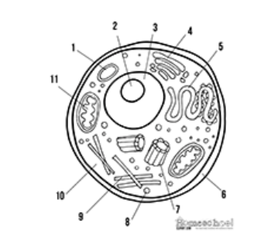

a) Label the following parts of the animal cell: (3)

Part 2………………………..

Part 5……………………….

Part 8………………………

b) Describe how is the structure of the cell membrane related to its function? (3)

5. A medical research team investigated how quickly the body deals with glucose after a meal. They studied the blood glucose concentration of people who exercised versus those who did not.

Here are their results:

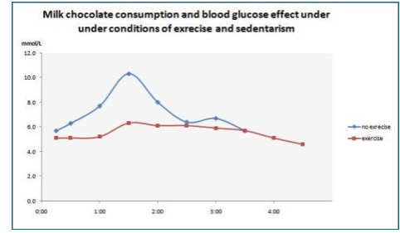

a) What organ in the body regulates blood glucose concentration? (1)

b) Explain how the stages that would bring about a return to normal blood glucose concentrations. (4)

c) Name one variable the researchers will have controlled.(1)

d) The researchers made the following conclusion:

**“Blood glucose returns to normal values for all people after 4 hours”**

To what extent do you agree with this conclusion. (3)

6. Scientists need to be able to interpret data in graphs to decide if there are trends in the results.

For each graph bellow, describe the trend. (4)

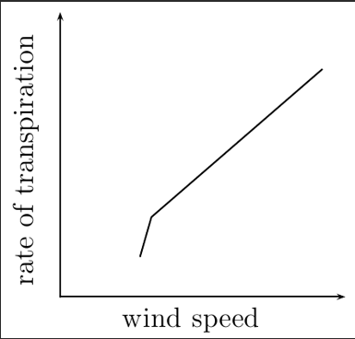 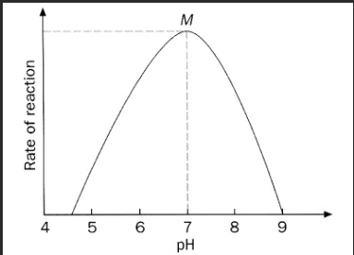

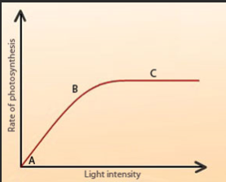 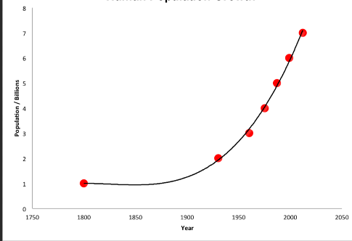

Suggested Mark Scheme:

