Independent Research Notes  COMPULSARY – Use the text book to read and complete notes in these sections – Miss C Chapman - CChapman@sirgrahambalfour.staffs.sch.uk |  | Independent Research Notes  COMPULSARY – Use the text book to read and complete notes in these sections Miss H Watson - HWatson@sirgrahambalfour.staffs.sch.uk
Characteristics of Skill and Skill Classifications  1.Learn the following key words  ACEFACE  Skill  Open/closed  Fine/gross  Self paced/externally paced  Discrete/continuous/ serial  High/low organisation  Simple/complex  2 .Using the above classifications. Classify the following sporting examples  - Football penalty kick (classify the taker and the Goal keeper)  - Rugby Tackle  - Gymnastics vault  You will need to draw the continua for each and fully justify your answers  3. Write a summary outlining any patterns you see with the classifications. Do certain classifications go together, what about type of sports and certain classification? What do you sport?  4. Complete as much reading on the topic as possible and use the topics on a page information provided and make a revision mind map/ revision sheet and revision cards |  | 1.Learn the following key words  Cholesterol  High density lipoproteins  Low density lipoproteins  Atherosclerosis  Stroke  Bradycardia  Hypertrophy  Hypertension  Blood pressure (systolic / diastolic)  Cardiac output / Stroke volume / Heart rate  Health  Fitness  Sedentary lifestyle  Task 1  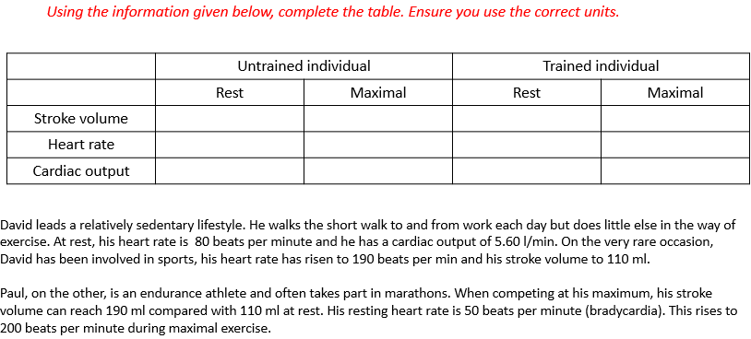  Task 2  Draw and fully label a diagram of the heart (including arteries/veins/valves). Use colours to show the flow of oxygenated and deoxygenated blood.  3.Complete the reading from the sheets provided and make a mind map or revision sheet
Extra work  Skill acquisition videos:  Watch the videos and write a summary, make a mind map or revision cards for each  https://www.youtube.com/watch?v=lYcbtd6v7mA  https://www.youtube.com/watch?v=UgfQIhepgCQ&list=PLzh4kOin3WArL_EFstlxY3tGb5JkKkFqS&index=2  https://www.youtube.com/watch?v=5uiPubH_S00&list=PLzh4kOin3WArL_EFstlxY3tGb5JkKkFqS&index=3  https://www.youtube.com/watch?v=Fuqr41TOviM&list=PLzh4kOin3WArL_EFstlxY3tGb5JkKkFqS&index=4  https://www.youtube.com/watch?v=KW2bZt-ZxoE&list=PLzh4kOin3WArL_EFstlxY3tGb5JkKkFqS&index=5  https://www.youtube.com/watch?v=WhIr5DfXNJk&list=PLzh4kOin3WArL_EFstlxY3tGb5JkKkFqS&index=6  https://www.youtube.com/watch?v=1YZhFIOgJ-Y&list=PLzh4kOin3WArL_EFstlxY3tGb5JkKkFqS&index=8  https://www.youtube.com/watch?v=GfhQT5tHRXw&list=PLzh4kOin3WArL_EFstlxY3tGb5JkKkFqS&index=9  https://www.youtube.com/watch?v=dP-5UgFIWkU&list=PLzh4kOin3WArL_EFstlxY3tGb5JkKkFqS&index=10  https://www.youtube.com/watch?v=-RlY_FQZpLU&list=PLzh4kOin3WArL_EFstlxY3tGb5JkKkFqS&index=11 | Extra work  Anatomy and physiology videos:  Watch the videos and write a summary, make a mind map or revision cards for each  https://www.youtube.com/watch?v=y6QJceOAVY0  https://www.youtube.com/watch?v=_UIpBJLfaIc  https://www.youtube.com/watch?v=9rAsqoGhwfM  https://www.youtube.com/watch?v=vFRkSB46bl8  https://www.youtube.com/watch?v=JtBtk00EiVM  https://www.youtube.com/watch?v=X9ZZ6tcxArI  https://www.youtube.com/watch?v=VWamhZ8vTL4  https://www.youtube.com/watch?v=sSq3gssS4KM
Expectations

- Please set up an A level PE folder, in the folder then set up one folder for Miss Chapman’s work and one for Miss Watsons work. Save the tasks in the correct folder.

- Please complete all of the compulsory tasks and save in on your computers, these can be then emailed across. Revision cards and revision maps or anything you do on paper, keep in a folder and you can send photos of these as evidence.

- I would strongly suggest buying one of these text books. Please note: Book one is for the first year only (approx. £28.99). The combined book (second image) will cover everything in the whole two year course and save you buying a book two in the second year (approx. £39.99). If you buy the combined book, please note you DO NOT need to buy book one also.

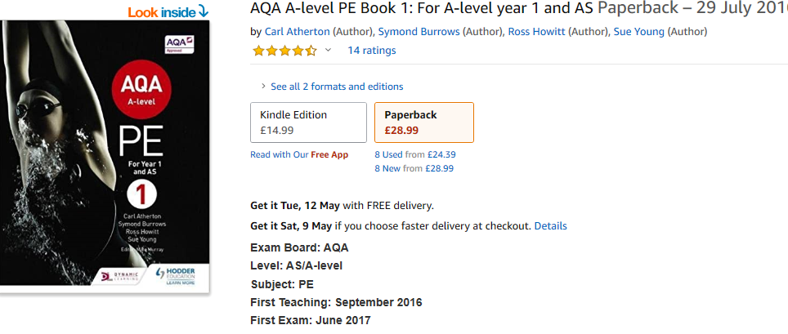

T
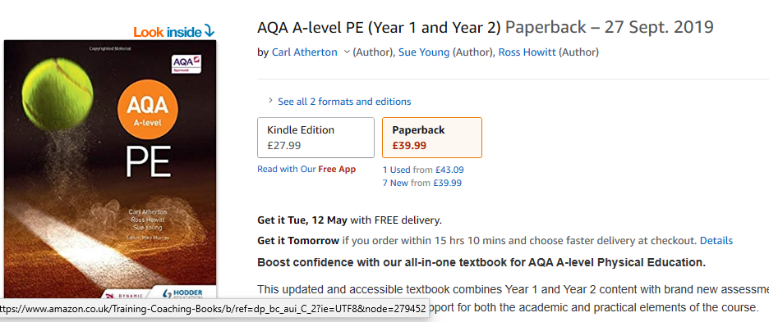

- Please note that 30% of this course is based on your practical performance and performance analysis. You must provide evidence of your sport you intend to take – this could be video evidence, ranking on the internet, handicap or any other relevant evidence. Please note your practical ability will be assessed using video evidence – you are responsible for submitting your own video and ensuring it is correctly edited (you will be provided with all the information).

Given current circumstances, clearly video evidence and sports participation is difficult, but please do keep in mind what you will eventually need to submit

