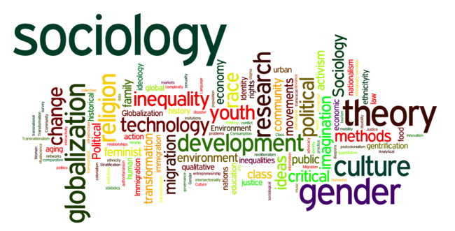

SOCIOLOGY TRANSITION 1

WHAT IS? (write in a definition)

PSYCHOLOGY
POLITICS
ECONOMICS
SOCIOLOGY

Studying society means you have to know about:
- History
- British politics
- Geography
- Current affairs
- Foreign cultures
- How language shapes the way we see things
- The effect of the media on beliefs and behaviour
- Theories about society
- Studies of events in society
- Ways to study society
- Problems in studying society

LET’S ASK SOME SOCIOLOGICAL QUESTIONS
Imagine that you would be are sitting in a classroom in a Staffordshire state school in central England.
How did you come to be here?
Why is this a state school? Why is it not an academy?

Why aren’t you at Stafford Grammar? Eton College?
Why is the school largely monoracial? Why are there relatively few students with non-British family backgrounds?
Is the school in a well-off or relatively poor area of town?

Is Stafford a rich part of England or not? Where are the richer and poorer parts of England?
What is the purpose of school education?
Why are you still in education? Do you have a choice?
What does school teach you, apart from the subjects themselves?
Can you be the real you at school? At home? Anywhere?
If you were asked to identify yourself in 3 words, what would they be?
What did you miss out?

SUBMISSION

- ANSWER THE QUESTIONS ON PAGES 2-4 BY SAVING AS A SEPARATE DOCUMENT
- NAME THIS DOCUMENT WITH YOUR NAME AND SOCIOLOGY 1
- (E.G. JANE SMITH:SOCIOLOGY 1)
- YOU CAN THEN USE AS MUCH SPACE AS YOU REQUIRE TO ANSWER EACH QUSTION, EXPANDING THE ANSWER SPACE AS MUCH AS NEEDED.
- SEND THE COMPLETED DOCUMENT TO griffin.p@kevi.org.uk
- DEADLINE IS 19TH JUNE 2020

- IF YOU HAVE TO ANSWER BY WRITTEN DOCUMENT, POST/DELIVER IT TO KING EDWARD VI BY 19TH JUNE, ADDRESSED TO MR GRIFFIN (SOCIOLOGY).

